*Anshika Banerjee and Chris Osigwe Okhamera*

*MSc. Information Systems with Computing | Dublin Business School*

*web and mobile technologies -class assignment 2 – development of an android application.*

*Group Project.*

*By*

*Anshika Banerjee (10372528)*

*Chris Osigwe Okhamera (10370308)*

*Module Code: B8IT061*

*Module Leader:* *John Rowley*

*DATE: APRIL 2018.*



Table of Contents

INTRODUCTION 1

DESIGN OF APPLICATION 1

METHODOLOGY 1

REQUIREMENTS 1

SCREENSHOTS 1

LIMITATIONS 1

LEARNING OUTCOMES 1

CONCLUSION 1

REFERENCES 1

BIBLIOGRAPHY 1

# INTRODUCTION

Android is an open source and Linux-based Operating System for mobile devices such as smartphones and tablet computers. Android was developed by the Open Handset Alliance, led by Google, and other companies. Android offers a unified approach to application development for mobile devices which means developers need to develop only for Android, and their applications should be able to run on different devices powered by Android.

Thus, for this assignment we used Android Studio, to develop an App which fulfils the requirements of the assignment.

# DESIGN OF APPLICATION

The design of the application is shown in the screenshots below.

# 

Main Activity.

# 

URL Connections

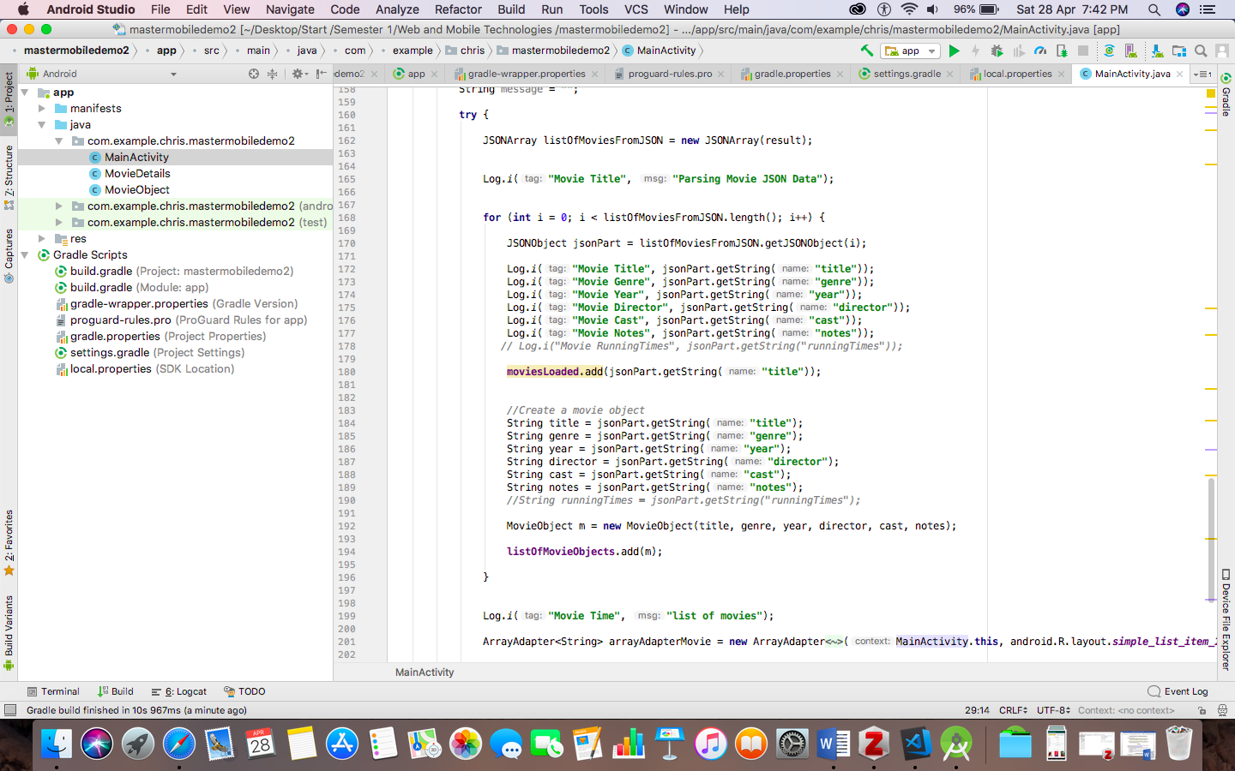

List of Movies JSON Query

# METHODOLOGY

# REQUIREMENTS

1. Create an Android mobile application that meets the requirements outlined below. Where you find ambiguity in the requirements, you are expected to use your initiative and make a judgement call to complete the assignment.
2. Produce a short report (300-1000 words) describing the challenges you each faced, alternative libraries you might have used (such as parsing JSON) and what you have learned in the process.

The above-mentioned requirements are fulfilled as reported in this report.

# SCREENSHOTS

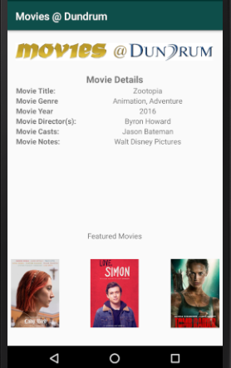

Application Page 1

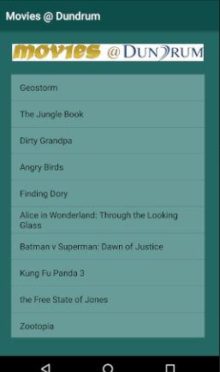

Application Page 2

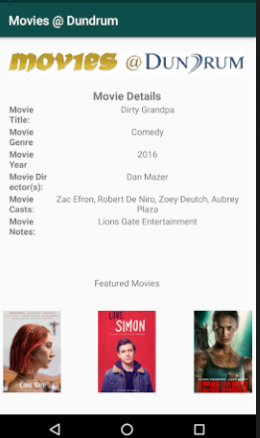

Application Page 3.

# LIMITATIONS

1. Design level and Production level coding is not separated.
2. Can have a better User Interface.
3. Code can be optimised.
4. Certain bugs need to be fixed for it run on every machine.

# LEARNING OUTCOMES

1. Describe the basic components of an Android application.
2. Define the lifecycle methods of Android application components.
3. Describe the basics of event handling in Android.
4. Describe the basics of graphics and multimedia support in Android.
5. Demonstrate basic skills of using an integrated development environment (Android Studio) and Android Software Development Kit (SDK) for implementing Android applications.
6. Demonstrate through a simple application the understanding of the basic concepts of Android.
7. Parsing JSON data into the app.

# CONCLUSION

Thus, we have fulfilled all requirements of the assignment and learnt android app development in the process.

# BIBLIOGRAPHY

‘Android | 9to5Google’ (no date). Available at: https://9to5google.com/guides/android/ (Accessed: 28 April 2018).

*Android Application Development & Programming* (no date) *Learning Tree International*. Available at: https://www.learningtree.com/courses/ (Accessed: 28 April 2018).

*Android (operating system) - Wikipedia* (no date). Available at: https://en.wikipedia.org/wiki/Android_(operating_system) (Accessed: 28 April 2018).

*Google APIs for Android* (no date) *Google Developers*. Available at: https://developers.google.com/android/ (Accessed: 28 April 2018).

*JSON Introduction* (no date). Available at: https://www.w3schools.com/js/js_json_intro.asp (Accessed: 28 April 2018).

*movies at dundrum - Google Search* (no date). Available at: https://www.google.com/search?client=safari&rls=en&ei=HsfkWuGwF4vYgAaXlqqYDQ&q=movies+at+dundrum&oq=movies+at+&gs_l=psy-ab.3.0.0i131k1l2j0l3j0i131k1j0l4.20205.24965.0.26213.10.10.0.0.0.0.237.1398.0j9j1.10.0.foo%2Ckpnr%3D200%2Ccfro%3D1...0...1.1.64.psy-ab..0.10.1397...0i131i67k1j0i67k1.0.bs_Y1QfjUR8 (Accessed: 28 April 2018).

www.admit-one.eu, A. O.- (no date) *Movies @ Cinemas, Movies @ Swords, Movies @ Dundrum, movies, film, events, opera, dublin*. Available at: http://www.movies-at.ie/ (Accessed: 28 April 2018).

*W3Schools Online Web Tutorials* (no date). Available at: https://www.w3schools.com/ (Accessed: 28 April 2018).